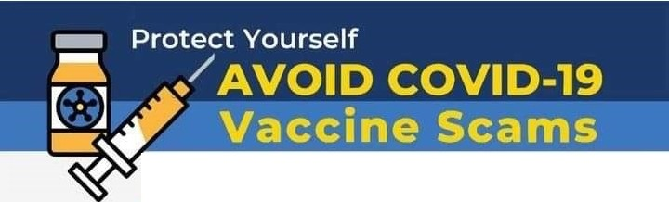

As COVID-19 vaccine distribution begins, here are signs of potential scams:
- You are asked to pay out of pocket to get the vaccine.
- You are asked to pay to put your name on a vaccine waiting list or to get early access.
- Advertisements for vaccines through social media platforms, email, telephone calls, online, or from unsolicited/unknown sources.
- Marketers offering to sell or ship doses of the vaccine for payment.
-i,Protect Yourself. Do not give out your personal information to unknown sour ces.

I If you believe you have been the victim of
- COVID-19 fraud , immediately report it to:
- HHS-OIG Hotline: 1-800-HHS-TIPS I tips.hhs.gov
- FBI Hot line : 1-800-CALL-FBII ic3.gov
- CMS/Medicare Hotli ne: 1-800-MEDICARE
•
For accura te, up -to- d ate
info rmation ab o ut
COVI 0 - 19, visit:
o ig .hhs.gov/coronavirus fbi.gov/coronavirus justice.gov/coronavirus

